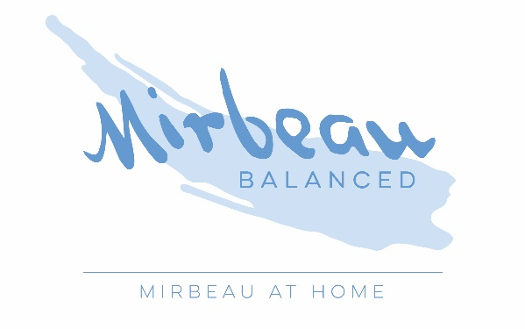
4-Week Health Challenge FAQ

How do I make my first appointment?
We will contact you the week before the Challenge starts to book a pre-evaluation appointment, which will occur during week 1. Virtual appointments will occur on Zoom. You will be emailed a join link 30 minutes prior to start time. Upon booking your pre-evaluation appointment, a form link will be emailed to you. Please complete the form prior to your first appointment. During your pre-evaluation, you and your coach will come up with a schedule for your weekly coaching appointments. These will be your personalized training sessions where your time will be spent working toward your goals and creating a personal health plan customized for your needs and lifestyle. These weekly appointments should occur at the same time each week for four weeks.
What will the weekly virtual group call consist of?
The weekly group calls will be customized to the private group that is participating in the Challenge to provide an added element of support, which has been proven to be helpful in providing additional motivation to continue moving forward in the process of achieving health goals. The weekly calls will be a combination of mindfulness-based exercises and there will also be opportunities for participants to engage as they feel comfortable throughout the program. The 50-minute weekly group calls will occur on Wednesdays 7:00pm.

How do I sign up for the weekly group call?
The weekly group call will occur on Zoom. To receive the join link, you will need to pre-register. A link will be emailed to you 30 minutes prior to start time (please be sure to check your spam folder). To start, download our Mirbeau Balanced app. Your first time, you may click ‘Forgot your password’ to complete the set up. Then, go to ‘Book’, select the class ‘Virtual Health Challenge Call’. Finally, click ‘Book’.

How do I sign up for other live-stream classes and view the on-demand library?
As a bonus, you also receive unlimited access to over 70 live-stream classes offered 7-days-a-week plus our entire video-on-demand library for the duration of the Challenge! These classes include a variety of Strength, Yoga, Tai Chi, Pilates, Barre, Balance, Mobility, Cardio Tone as well as specialty classes like Low Impact Cardio and Pelvic Conditioning. You will pre-register for these live-stream classes just as you will for the weekly group call and receive the join link 30 minutes prior to start time. To view our video-on-demand library, click the ‘Video’ tab within the Mirbeau Balanced app.

What is the best way to stay in communication during the Challenge?
The Coaches will also be communicating with Challenge participants with helpful tips and motivation. This will occur through email and also through group messaging. Please download the GroupMe app that we’ll use for our group communications. You will be added to our private Challenge group. Other group participants will only be able to view your name to protect your privacy. To be respectful of others, we request that individual questions be emailed to us at mirbeauwellness@mirbeau.com

What if I need to reschedule my appointment?
We request 24-hours’ notice to reschedule an appointment. A $10 no-show fee will be charged for missed appointments.

We look forward to getting to know each of you and helping you achieve your goals!

